**CSBP119 – Algorithms and Problem Solving**

**Assignment 03**

Total Marks: 10 points  
Please solve the following questions individually. Show all your work.

**Name: ID: Section:**

**Q-01 (USE NETBEANS)** Write a Java program to play the guessing number game. The program generates a number, the user guess the number, then the program will display one of the following: correct, smaller, greater. The program keeps doing this until the user guesses the number correctly.

* Modify the program to count the number of guesses the user made
* Modify the program to change the roles of the user and the program

**Q-02 (USE NETBEANS)** Write a Java program to read from file a customer’s account number, account balance at beginning of month, transaction type (withdrawal, deposit, interest), transaction amount. Then print to a file the account number, beginning balance, ending balance, total interest paid, total amount deposited, number of deposits, total amount withdrawn, number of withdrawals.

**Q-03 (USE NETBEANS)** Fibonacci formula for any Fibonacci sequence: an = an-1 + an-2

Input: first two Fibonacci numbers in sequence, position in sequence of desired Fibonacci number (n)

Output: nth Fibonacci number

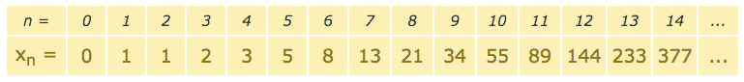

**Q-04 (USE NETBEANS)** Write a java program that computes the amount your deposit, if your initial amount is 1000, and you left your money for 10 years and on average the deposit grew by 5% each year.

**Q-05 (USE NETBEANS)** Write a program to find the sum of the digits of a number. (Use the do ...while)